If confronted by fire – the right actions
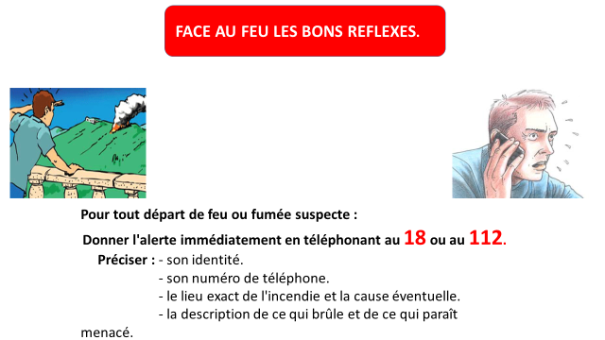
In the event that you suspect the presence of smoke or fire :
Telephone 18 or 112 immediately

If you are in your (masonry) home – with the grounds correctly cleared and maintained :
Do not attempt to evacuate the area – your home is your best protection. Evacuation is the exception and should only be undertaken on instruction from the authorities (police, fire brigade…)
The rule is containment
Attempts to flee can result in congestion/traffic jams which impede the rescue services and may endanger your lives.
